Introduction to Machine learning

Among loads of ML Problems here are the two most common ones:

* Regression problem
  + E.g. Predicting the price of a stock next year
* Classification problem
  + E.g. Predicting whether a subject will like or dislike a certain movie

**Types of machine learning algorithms**

**Supervised machine learning**

This involves training data and testing data. It includes an input variable and an output variable. This means someone is there. The problem with supervised learning is that is required annotation of datasets which can be time consuming, costly and introduces human error.

**Unsupervised learning**

Deep learning model is handed a dataset without explicit instructions on what to do. The training set is a collection of examples without a specific desired outcome or correct answer. The neural network then attempts to automatically find structure in the data by extracting useful features and analysing its structure.

Depending on the problem at hand the unsupervised learning model can organize the data in different ways:

* **Clustering**
  + Data is group by similar features. E.g. Separation of bird species by feather, height etc
* **Anomaly detection**
  + Unsupervised learning can be used to flag outliers in a dataset. E.g. fraud detection in a bank transaction
* **Association**
  + Identification of attributes in a data which are associated with another attributes that they are commonly associated with. E.g. Recommended shopping list on Amazon
* **Autoencoders** 
  + Recreating input data from a summarized data. E.g. Removal of noise from a photo taken at night

**Reinforcement learning**

The use of rewards and penalties to train the machine to complete a certain task in the most efficient way possible. A real-life example of this is a video game, where you are rewarded for picking up intel and punished if you step into a claymore.

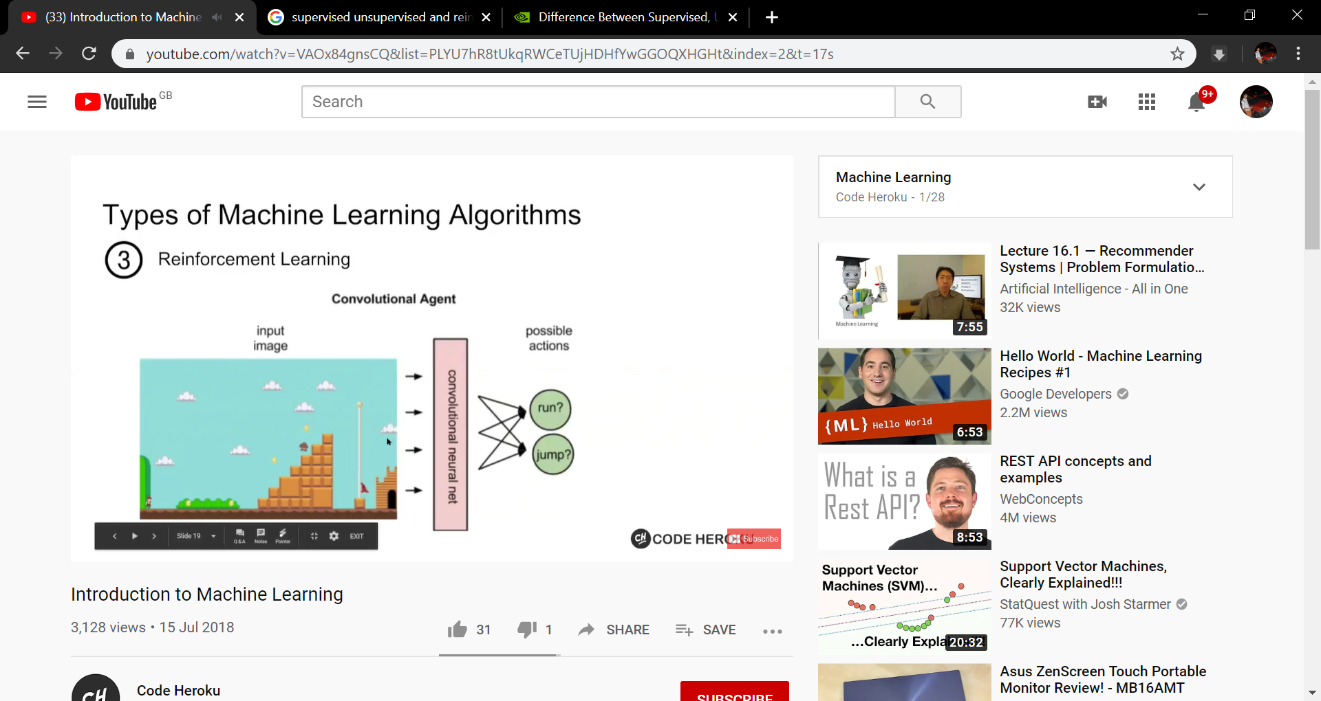

Figure : Example of reinformentn learning in play